Project Design Phase-II
Data Flow Diagram & User Stories
Date | 07 July 2026
Team ID | SWTID-2026-2247
Project Name | Emotion Detection and Learning Support Engine
Maximum Marks | 4 Marks

Data Flow Diagrams:
A Data Flow Diagram (DFD) shows how information moves through the Emotion Detection and Learning Support Engine — how data enters and leaves the system, what transforms it, and where it is stored. Below are the Level 0 (context) and Level 1 (detailed) diagrams for the system.
Level 0 — Context Diagram
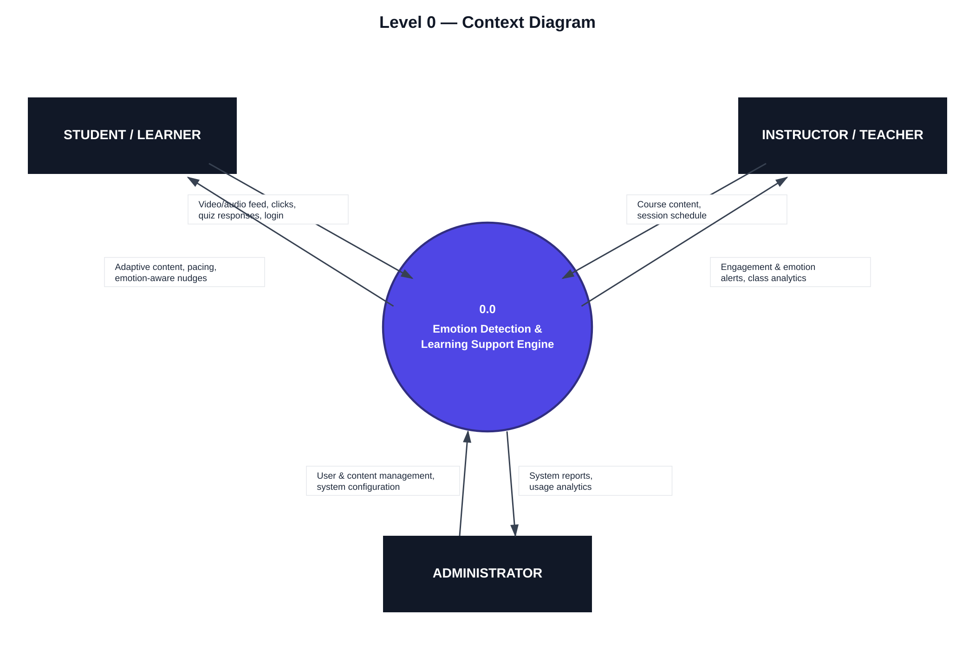
Level 1 — Detailed Data Flow Diagram
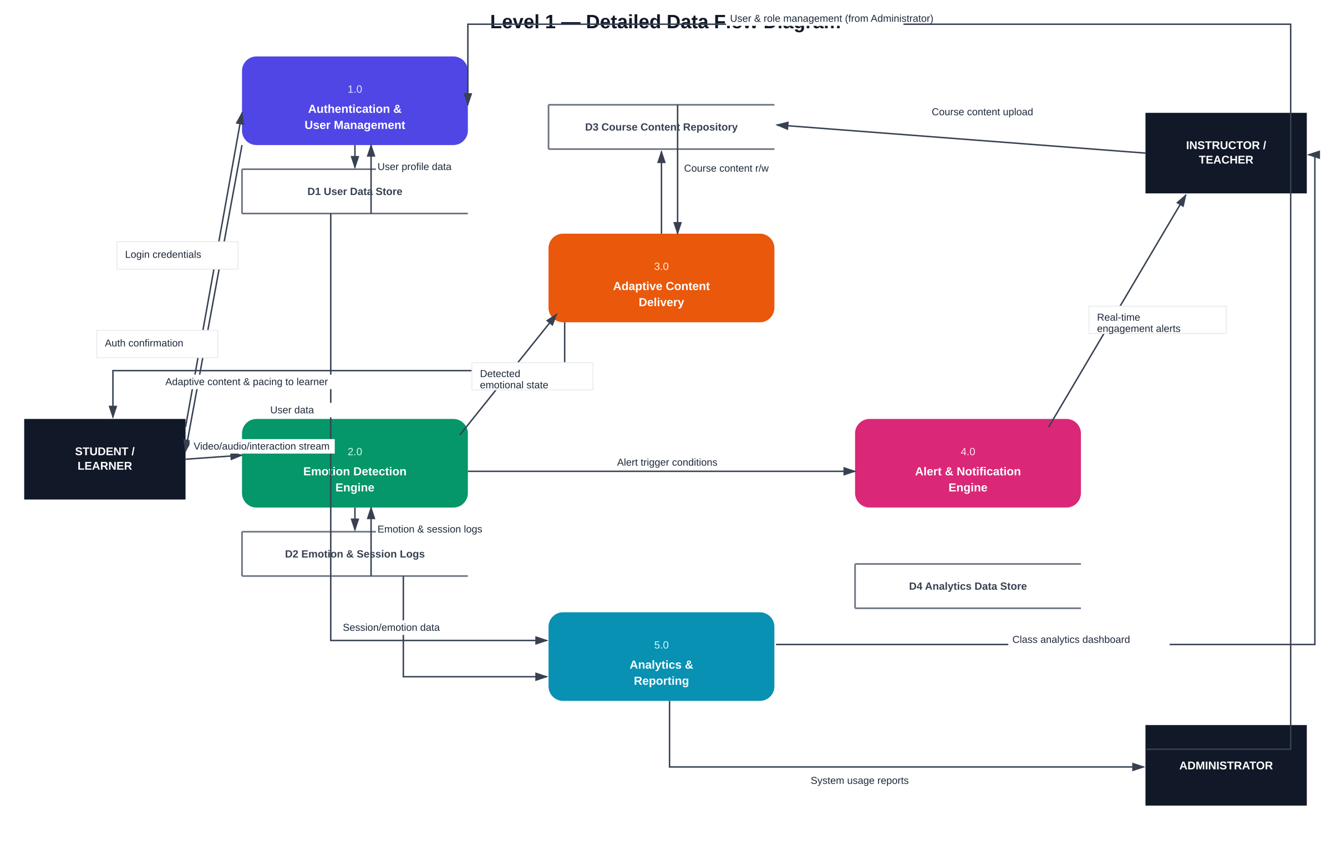
User Stories
User stories for the Emotion Detection and Learning Support Engine, covering the Student (Learner), Instructor (Teacher), Administrator, and the System (AI Engine) itself.
User Type | Functional Requirement (Epic) | User Story Number | User Story / Task | Acceptance Criteria | Priority | Release
Student (Learner) | Registration | USN-1 | As a learner, I can register by entering my name, email, password, and confirming my password. | I can create an account and land on my personalized dashboard. | High | Sprint-1
 |  | USN-2 | As a learner, I receive a confirmation email once I register. | I receive an email and can confirm my account via a verification link. | High | Sprint-1
 |  | USN-3 | As a learner, I can register/log in using Google or institutional SSO. | I can access my dashboard using Google/SSO login. | Medium | Sprint-2
 | Login & Consent | USN-4 | As a learner, I can log in with my email and password. | I am authenticated and redirected to my dashboard. | High | Sprint-1
 |  | USN-5 | As a learner, I am asked for explicit consent before my camera/microphone is used for emotion detection. | I see a clear consent prompt and can opt in/out before any capture begins. | High | Sprint-1
 | Emotion Capture | USN-6 | As a learner, the system observes my facial expressions and engagement during a lesson to detect confusion, boredom, or stress. | My emotional/attention state is detected in real time with at least 80% accuracy in testing. | High | Sprint-2
 |  | USN-7 | As a learner, I can pause or disable emotion tracking at any time during a session. | A visible toggle lets me turn tracking off instantly without losing my session. | Medium | Sprint-2
 | Adaptive Learning | USN-8 | As a learner, I receive simplified content or a short recap automatically when I appear confused. | Simplified content/recap appears within seconds of confusion being detected. | High | Sprint-3
 |  | USN-9 | As a learner, I get a short break suggestion or an engaging activity when I appear bored or fatigued. | A break/engagement prompt is shown after sustained low-engagement is detected. | Medium | Sprint-3
 |  | USN-10 | As a learner, I can view my own emotional/engagement trends over time. | I can see a simple chart of my focus and mood trends across past sessions. | Low | Sprint-4
 | Dashboard | USN-11 | As a learner, I can view my course progress, pending tasks, and upcoming deadlines on one dashboard. | Dashboard loads with progress %, pending tasks, and deadlines correctly listed. | Medium | Sprint-2
Instructor (Teacher) | Course Management | USN-12 | As an instructor, I can upload and organize course content (videos, slides, quizzes). | Uploaded content appears correctly under the right module/course. | High | Sprint-1
 | Live Alerts | USN-13 | As an instructor, I receive a real-time alert when multiple students appear confused or disengaged during a live session. | An alert appears on my dashboard within seconds of the threshold being crossed. | High | Sprint-3
 |  | USN-14 | As an instructor, I can see which specific topic triggered a confusion spike. | The alert links directly to the timestamp/slide that caused the spike. | Medium | Sprint-3
 | Class Analytics | USN-15 | As an instructor, I can view a class-level analytics dashboard showing aggregate engagement and emotion trends. | Dashboard shows engagement graphs per session, updated after each class. | High | Sprint-4
 |  | USN-16 | As an instructor, I can export session analytics as a report (PDF/Excel). | I can download a correctly formatted report for any selected session. | Low | Sprint-4
Administrator | User Management | USN-17 | As an administrator, I can create, edit, and deactivate learner and instructor accounts. | Account changes are saved and reflected immediately in the system. | High | Sprint-1
 | System Configuration | USN-18 | As an administrator, I can configure emotion-detection sensitivity thresholds and alert rules. | Changed thresholds take effect for all new sessions without a restart. | Medium | Sprint-3
 | Reporting | USN-19 | As an administrator, I can view platform-wide usage and performance reports. | Reports show accurate active-user counts, engagement averages, and system uptime. | Medium | Sprint-4
 | Data Privacy | USN-20 | As an administrator, I can review and manage data retention/deletion settings for emotion data. | I can set a retention period and trigger deletion in compliance with policy. | High | Sprint-2
System (AI Engine) | Model Monitoring | USN-21 | As the system, I log model confidence scores for each emotion prediction for later review. | Every prediction is logged with a confidence score and timestamp. | Medium | Sprint-3
 | Failover | USN-22 | As the system, I fall back to a neutral/no-adaptation mode if the emotion-detection service is unavailable. | Learners continue their session uninterrupted even if detection fails. | High | Sprint-2

